ZCAD
v0.9.8

General information.
The ZCAD program (hereinafter referred to as the program) allows you to automate some processes when executing the graphic and textual parts of the electrical sections of the project:

General features:
- equipment placement on plans
- manual connection of equipment with cable lines with length calculation
- automatic connection of equipment with cable lines with length calculation
- formation of cable magazine
- formation of blanks for the connection scheme
- formation of equipment specifications and materials ??
- formation of graphic signatures of cable routes on the plans

EM (power equipment)

OPS (fire alarm system)
- automatic placement of fire detectors
- automatic numbering of fire detectors in loops
- formation of a wiring diagram for detectors in cables

In the current version of the program there may be discrepancies with this manual.

Installation, Startup and Initial Setup
The program does not require installation and is distributed in the archive, which is enough to unzip to any folder on the user's computer (preferably without Cyrillic characters in the path)
To run the program, you must run the file zcad.exe. The output of vector graphics in the program is organized using OpenGL, for the correct operation of the program, the video system of the computer must support this graphic library. GDI graphic backend under development
User interface
The working window of the program:
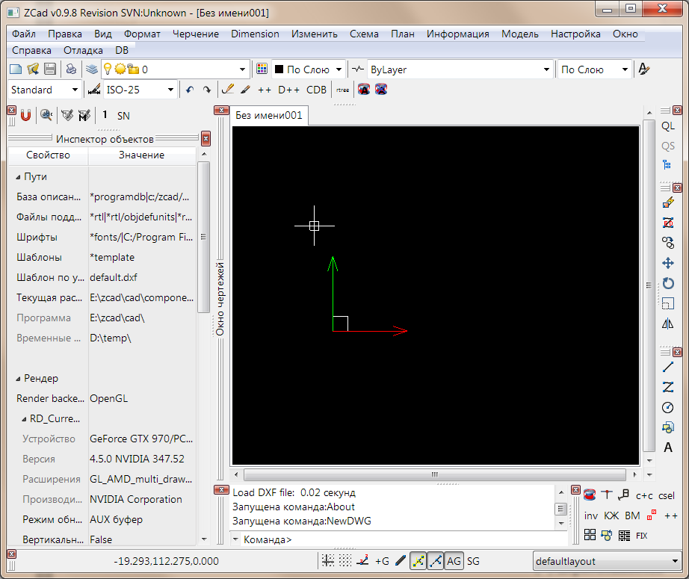
It consists of “docked” object inspector windows, a drawing window, a command line and toolbars.
The launch of the program is possible with the following command line keys:

- NLL - NOLOADINGLAYOUT shutdown of loading the file of docking of windows
- SI - STANDARTINTERFACE full docking off, ZCad works in single-window mode (very unfinished)
- UPDATEPO - Disable loading localization, the English version will be launched. Also in this mode, the command to update the localization files is available.
- NOSPLASH - disable splash screenshots
- the path to the file.dxf - open the specified working file with the program.
The basic format of the program data storage file – DXF version 2000, with the following limitations:
- Not supported THICKNESS
- Not supported ELEVATION
- Sheets not supported, only MODEL, when loading a file containing sheets, primitives from them will be transferred to the model
DXF primitives supported by the program:
Табл.1
Primitive | Degree of support
LINE | completely
CIRCLE | completely
ARC | completely
POINT | completely
LWPOLYLINE | completely
3DPOLYLINE | completely
TEXT | completely
MTEXT | completely
INSERT (вставка блока) | partly - attributes are not supported
ELLIPSE | (*)
3DFACE | (*)
SOLID | (*)
SPLINE | (*)
Размерные примитивы | Not all (*)
(*) being finalized

This list will be expanded, but there will not be full support for all DXF primitives.

General principles of working with the program
Files processed by ZCAD can be edited in AutoCAD (and other CAD programs) without using the commands that clean up extended primitive data. If the extended data of the primitive is destroyed, during subsequent processing of the ZCAD, it will be perceived as a standard primitive, i.e. the cable will become just a polyline, and the device will be a regular block. Also, some ZCAD primitives cannot be copied in other programs..
Preparation for work.
First you need to prepare a file with plans in the program with more complete support for the DXF2000 format (for example, AutoCAD):
- Break complex primitives to fully supported primitives from Table 1 (including primitives inside blocks);
- Clear the file from “unnecessary” information (layer filters, unnecessary block definitions, sheets (transfer necessary information from sheets to a model), etc.);
- Move primitives closer to the origin;
- Save as DXF2000.
The prepared file can be loaded into the program for work.
The ZCAD project is a dxf file with graphic information, if the graphic devices in the project are associated with specific equipment from the program database, then additional information about the connections is saved to a file with the dbpas extension.
Working in ZCAD is like working with AutoCAD. When drawing, bindings, tracing are used, execution of commands is possible either by typing in the command line, or by selecting in the menu or on the toolbar. Parameters for the operation of commands, if necessary, are set in the object inspector.
But there are differences:
- For teams that require the selection of objects, a pre-selection is adopted, i.e. at the time of execution of the command, the objects must have already been selected.
The following shortcuts are available for quick execution of commands:

Табл.2
Combination | Action
CTRL+O | Open drawing file
CTRL+N | New drawing
CTRL+S | Save drawing
CTRL+F4 | Close drawing
CTRL+Q | Close the program
CTRL+Z | Undo last action
CTRL+SHIFT+Z | Repeat last action
CTRL+X | Cut out
CTRL+C | Copy
CTRL+SHIFT+C, CTRL+INS | Copy with base point
CTRL+V, SHIFT+INS | Insert
DEL | Delete
CTRL+A | Select all
CTRL+SHIFT+A | Deselect all
CTRL+F | To find
CTRL+T | Open the project “deev” window
CTRL+R | Regenerate all
F2 | View command line log window
ALT+S | Snap and trace settings
CTRL+TAB | Next drawing tab
SHIFT+CTRL+TAB | Previous Drawing Tab
CTRL+A | Choose all
ESC | Cancel command / selection
Double tap of mouse buttons, HOME | Show all
END | Show selection
Pressing the left mouse button + move the cursor | Pan
Press CTRL + mouse button + move, CTRL + cursor | 3D camera rotation
Mouse wheel rotation, PGUP, PGDOWN | Camera scaling / movement with perspective projection

Save and open project file
Savе:
Command: | SaveAs
Icon:
Menu intem: | File / Save As
Open:
Command: | Load
Icon:
Menu intem: | File / Open
Identify all of the basic functions that are required, including the file type - the most common QS and QL objects on the file. Сохранение и закрузка в случае производствует від файла autosave.dxf.

Regeneration of project graphic information
In some cases, it is necessary to force the program to update the graphic information, for example, to update the callout when the situation changes in its area of operation or the cable recalculation when the device connected to it is removed. This can be done in the following way:
Command: | Regen
Icon:
Menu intem: | View / Regenerate

You can also regenerate only the ZCAD primitives (devices, cables, callouts), useful on very large drawings, with significant costs for complete regeneration:
Command: | RegenZEnts
Icon: | RZ
Menu intem: | View / Regenerate?

Additional primitives provided by the program
Variables
The program allows you to bind a set of additional typed properties to any primitive, these properties are stored in dxf in the primitive's extended data. This mechanism is used, for example, to “emulate” attributes of auto-cad blocks, to set additional parameters for primitives (for example, the designation for HBO)
The variables attached to the primitive are displayed on the Variables tab in the object inspector, where you can change their values.

Primitive DEVICE (Device).
The symbol of the equipment on the plan or diagram is the DEVICE (device) primitive in terms of ZCAD. Unlike the standard DXF - INSERT primitive (block insert), it contains both primitives and dynamic ones that are rigidly defined in the block description, and that can be moved relative to the insertion point. All device description names begin with the DEVICE_ prefix, when inserting a block with a name starting with DEVICE_, it will automatically be converted to the DEVICE primitive.

Methods for inserting blocks / devices into a drawing:
1. Insert some devices available in the menu Plan and Scheme.
2. Any block or device predefined in the program can be inserted into the drawing using the context menu of the “project tree”
Command: | ProjectTree
Icon: | Tree
Menu intem: | View / Project Tree
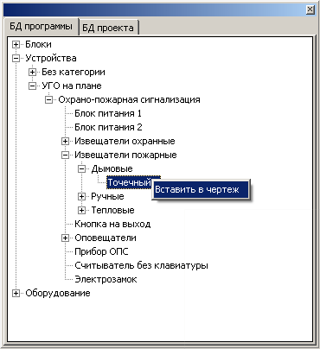

3. A block or device defined in a program or drawing can be inserted into the drawing using the command Insert
Command: | Insert
Icon:
Menu intem: | Черчение/Блок

In the properties of the command, you can select the name of the inserted block, specify the scale and also the angle of rotation of the inserted object.
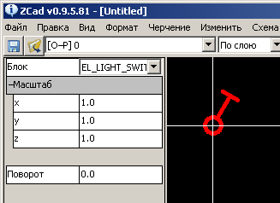

For example, to insert a smoke detector on a plan, you need to insert the DEVICE_PS_DAT_SMOKE block. If you simply insert the PS_DAT_SMOKE block, it will not be converted into a DEVICE primitive and will remain a DXF-INSERT primitive (block insert) without acquiring device properties.
The DEVICE_PS_DAT_SMOKE device consists of 2 blocks:
- DEVICE_PS_DAT_SMOKE – dynamic part of the device
- PS_DAT_SMOKE permanent part of the device
The permanent part of the device contains the actual UGO:
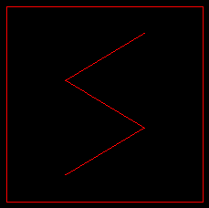
The dynamic part of the device contains additional primitives for example in this case:
- Device name designation
- Attached cable trimming circuit
- Connector for connecting cables (there may be several connectors, it is an independent device).


After inserting the device, it needs to assign some parameters. The set of parameters and their names by default are not yet definitively defined and may be changed in subsequent versions. Access to device parameters can be obtained in the Object Inspector on the Variables tab by clicking the appropriate device with the mouse.
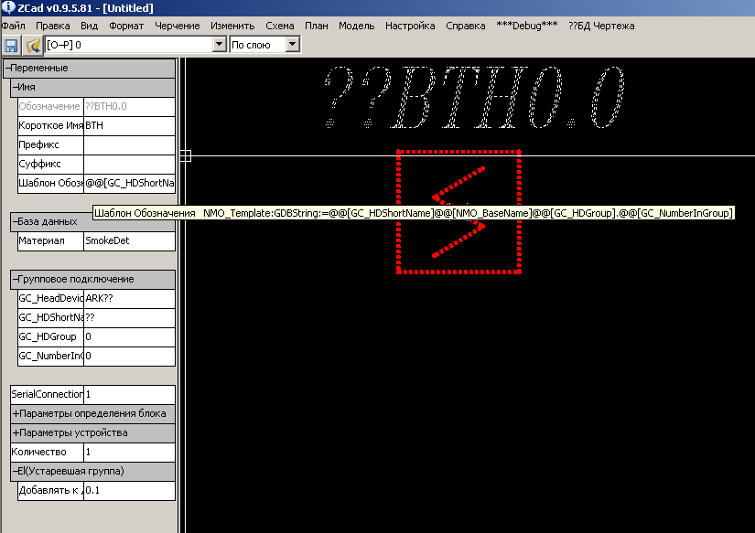
(in the debug version you can get full access to the object variable module using the VM button on the toolbar,

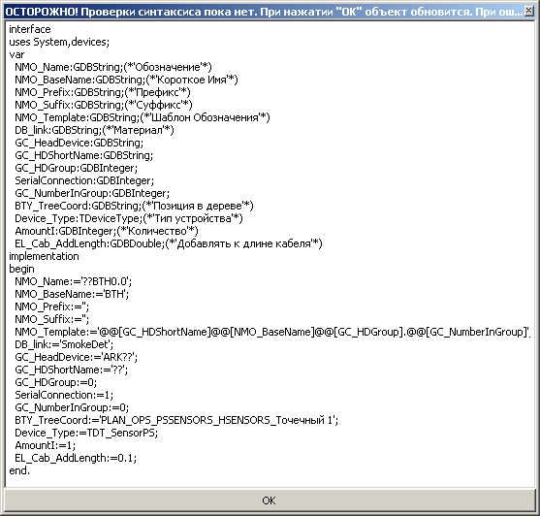
there you can add new properties, define their type, names and assign values)

To select a DEVICE primitive, you must specify the primitive with the mouse from the constant, not from the dynamic part of the device. Primitives from the dynamic part are independent and have their own properties. To simplify the selection procedure in the part of the program window there is a button

Переменная: | DWG_EditInSubEntry
Пиктограмма:
Описание: | Вкл./Выкл. отдельный выбор частей динамических объектов

DWG_EditInSubEntry - modifier selection mode, in the depressed state, it allows you to select devices by pointing the primitives from the dynamic part with the mouse, but in this mode you cannot edit dynamic primitives relative to the insertion point. In the pressed state, the primitives from the dynamic part of the device are selected separately, they can be edited.

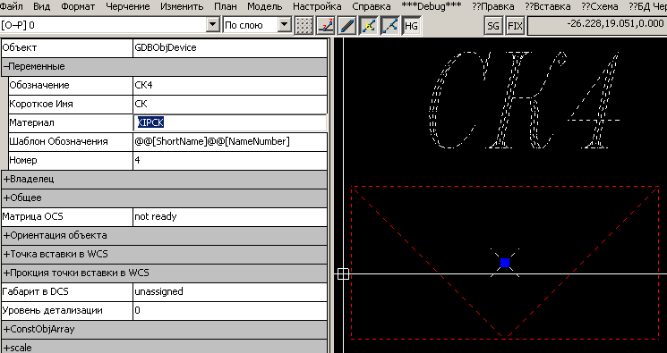
The selected device properties are available in the object inspector.
Notation Template (Name_Template String Variable) – Not mandatory property, sets a template for automatic formation of a designation. Instead of occurrences of @@ [variable name], the values of the corresponding variables are inserted into the designation. In this case, the properties “Short name” and “Number” will be substituted, respectively, as a result, the designation will be assigned “CK4”
Short name (string variable ShortName) – non-functional property, constant literal part of the notation
Number (integer variable NameNumber) – not a property, device number.
Designation (string variable Name) – Mandatory property, device designation. For example, this value is generated automatically.
If the primitive has the “Designation template” - “Designation” property is read-only. Manual editing will not produce any results. The program will still substitute the generated value, If there is no “Designation template”, you can specify any string.
Material (string variable Material) – optional property - material identifier that will be added to the specification
This way you can edit the default properties of the objects.
A more powerful, but also more complicated way to edit device properties is to use the object variable editor.
Command: | ObjVarMan
Icon: | VM
Menu intem: | Edit / Object Variable Manager

Окно менеджера переменных

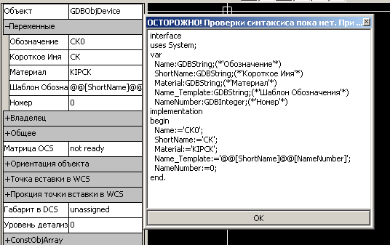

This is a simple text editor for a scripted pascal-like language.
The var section describes the variable properties of the selected object.
In the begin ... end section, properties are assigned initial values.
The text of the script can be edited, added-removed variables, not forgetting that if the variable is removed from the var section, it must be removed from the begin ... end section.
The format for describing new variables (semicolon required):
Variable Name: Variable Type; (* 'Property Name' *)
The format for assigning values ​​to variables (semicolon required):
Variable Name: = Variable Value;
String values ​​must be enclosed in apostrophes.
Some available types are:
GDBString | Текстовая строка
GDBInteger | Целое число со знаком
GDBDouble | Число с плавающей запятой

For a device, the most important property is the "Designation" (Name: GDBString; (* 'Designation' *)) by which the device will be identified in the program. The remaining properties by and large serve either to automatically generate the designation, or to reflect the specific properties of the device, for example, the number of the fire detector in the loop or the power of the electrical receiver.

Creating your own devices.
At this stage, the user’s creation of his device blocks is hampered by the lack of a specialized editor, but there are 2 ways:
1. Contact the developer.
2. Create a new device based on the existing one.
Existing device definitions are in the DXF files in the \ blocks \ el \ general \ folder.
_connector.dxf | -Коннекторы
_el.dxf | -Электротехнические устройства
_KIP.dxf | -Устройства КИПиА
_OPS.dxf | -Устройства пожаро-охранной сигнализации
_nok.dxf | -Устройства для редактора схем. В данный момент не поддерживается

The initial loading of these files is governed by the configuration file \ components \ autorun.cmd
File Contents:

;Коментарий
;*-путь к программе
load(*blocks\el\general\_connector.dxf)
load(*blocks\el\general\_el.dxf)
load(*blocks\el\general\_nok.dxf)
load(*blocks\el\general\_OPS.dxf)
load(*blocks\el\general\_KIP.dxf)
;load(*sample\test_dxf\ps.dxf)

Open the DXF file with the definition of the desired device in AutoCAD, insert the DEVICE_ [DEVICE] blocks and simply [DEVICE] into the file, copy the inserts into a new file, where we edit the geometry of the inserted blocks.
Do not forget about the contour of trimming cables, the lines forming it must be on the switched off layer SYS_DEVICE_BORDER in the DEVICE_ block [DEVICE]. We rename the inserted blocks to DEVICE_ [NEW DEVICE] and [NEW DEVICE], respectively, copy the inserts into the open DXF file and delete them so that only the definitions of the blocks remain. Save the DXF file. In the device definition files opened in AutoCAD, the _PURGE command cannot be executed automatically, only manually, deleting unnecessary definitions.
The created device can be inserted into ZCAD using the Insert command (DEVICE_ [NEW DEVICE])
If the created device requires a set of excellent properties, additional steps will have to be done:
Disable (comment out) in the file \ components \ autorun.cmd download files, leave only the file with the desired definition. For example, the new definition is in the _OPS.dxf file; accordingly, autorun.cmd should look like this:
;Комментарий
;*-путь к программе
;load(*blocks\el\general\_connector.dxf)
;load(*blocks\el\general\_el.dxf)
;load(*blocks\el\general\_nok.dxf)
load(*blocks\el\general\_OPS.dxf)
;load(*blocks\el\general\_KIP.dxf)
;load(*sample\test_dxf\ps.dxf)
Run ZCAD and enter the command in the command line
ObjVarMan(BD: DEVICE_[НОВОЕУСТРОЙСТВО])
BD prefixes: means editing a set of block definition variables. In the opened editor, edit the set of variables and their initial values. Save _OPS.dxf, close ZCAD, reset \ components \ autorun.cmd to its original state.

Расстановка устройств
On the plan loaded in ZCAD, we arrange the blocks of devices using the Incert () command or sub-items of the Plan menu
For placement of fire detectors in rectangular rooms, an automatic mode is available (PlaceSmokeDetectorOrto command), in which you need to specify opposite (diagonal) corners of rooms and room heights, the distance of the detector-detector, the detector-wall will be selected automatically in accordance with regulatory documents.
We assign the planned designations in the properties to devices.

Примитив CABLE (кабель)
Для соединения устройств в программе используется примитив CABLE - расширение стандартного DXF примитива 3DPOLYLINE.
Command: | El_Cable
Icon:
Menu intem: | План/Кабельная трасса/Новая трасса
Как и устройство, кабель имеет набор специфичных свойств в инспекторе объектов:
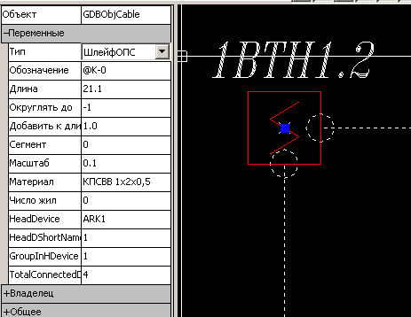

And the corresponding set of variables in the object's variable editor:
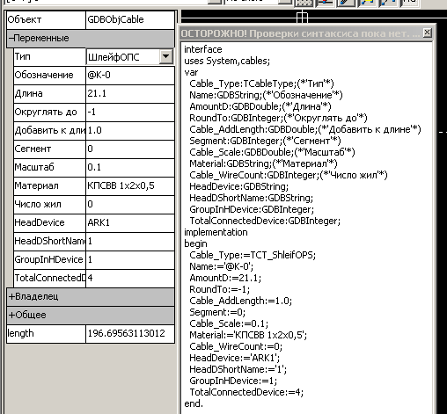
Designation (Name string variable) - mandatory property, cable designation. By default, the line “@ K-N” is filled with N automatically increased by 1 when a new cable is added. You can assign any value;
Length (GDBDouble variable AmountD) - mandatory automatically calculated property - cable length. It is calculated by the formula [the actual length of the polyline] * scale + [add to length] + [add to the length of all objects connected to the cable] is rounded to the sign indicated in Round to. If the Scale property has a negative value, the length is equal to its absolute value.
Round to (integer variable RoundTo) - indicates the direction and depth of rounding length. For example, 2 - round to hundreds, -1 - round to tenths;
Add to length (GDBDouble variable Cable_AddLength) —the property involved in the formula for calculating the length of the cable is the length added to the actual length, for example, the stock for stripping.
A segment (integer variable Segment) is a required property. It is necessary when the cable is shown on different planes by different CABLE primitives (For example, the cable starts on one fragment, ends on the other). In this case, the cables need to be assigned the same designation, and the segment should be increased by 1, starting from 0 for each piece of cable. During processing, the program will dock the pieces by incrementing the value of the Segment
Material (string variable Material) - optional property - identifier of the material to be added to the specification
The cable has a direction (it is formed when drawing, depending on the order of specifying the nodal points). The cable direction is visualized by an arrow at the last nodal point.
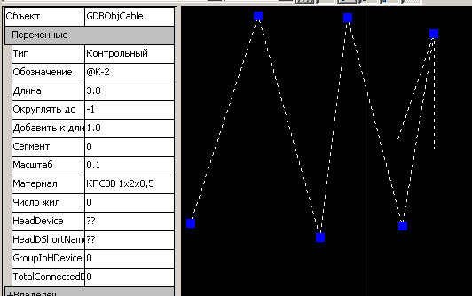

Cable direction can be changed:
Command: | El_Cable_Invert
Icon: | Отсутствует
Menu intem: | Plan / Cable route / Change direction
The result of the command:
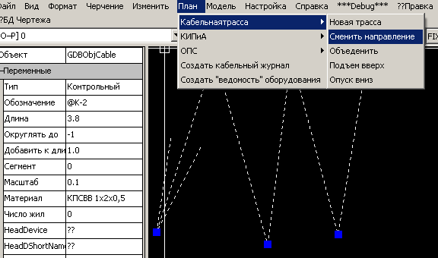

Editing the geometry of an existing cable
Often there is a need to edit the laying of the cable already drawn. If this is not related to the addition / removal of nodal points, you can simply select the cable and edit it by “handles” quick editing.
Add / Remove Vertices
Command: | PolyED
Icon:
Menu intem: | Edit / Polyline Editor
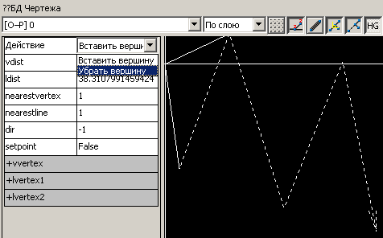
Modes of operation:
• Insert Vertex: First click - fixing the selected segment, second - adding a vertex to the segment.
• Remove Vertex: Click - deletes the marked vertex.

Combination of existing cables
Pull out 2 cables with adjacent start / end and run
Command: | El_Cable_Join
Icon: | Missing
Menu intem: | Plan \ Cable Track \ Combine

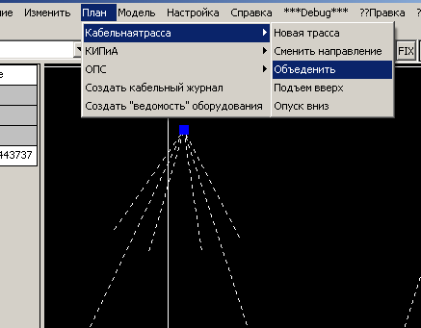

After combining, you may have to re-set the properties for the resulting cable.

Connecting the cable to the device
The device to which it is possible to attach a cable must have a connector in its composition (the dynamic part); when the cable's anchor point hits the device connector, the cable is connected and trimmed along the device's trimming contour. Additionally, the fact of the connection is visualized by circles at the edges of the trim:

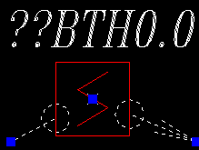
You can disable the auxiliary attachment visualization using the HG button on the top toolbar

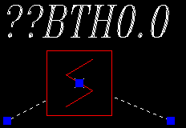

Allowed to connect the cable as to 2 devices (at the beginning and end):

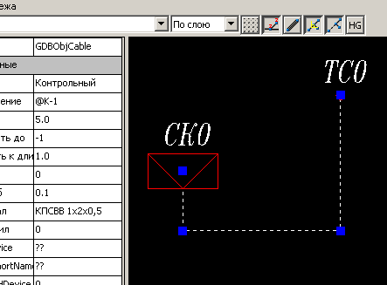

and in series to connect multiple devices:
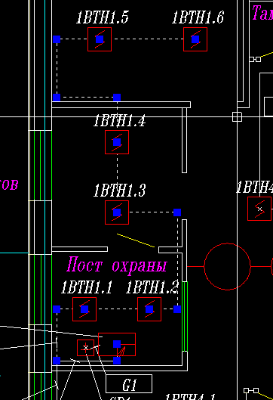

Organization of vertical sections of cable routes.
The program supports 3D cable routes, but to simplify the design process, “virtual” devices for lifting / lowering cables are supported:
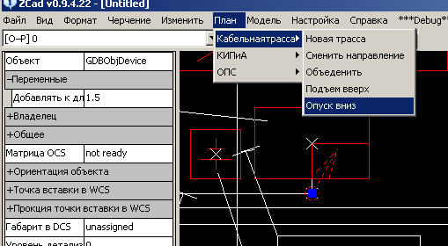

Accordingly DEVICE_ EL_CABLE_UP and DEVICE_ EL_CABLE_DOWN devices. When a cable is connected to these devices, the value of the Add to length parameter of the device is added to its length.

Signature cable routes and devices
For clarity in the drawing, you can arrange callouts with signatures of cable routes and devices.
Command: | El_Leader
Icon:
Menu intem: | Missing??
When the start line of the leader gets inside the device, a signature is automatically created with the device designation and a table of connected cables; when it hits the cable route, a table is provided with cables in place of the cable.
Leaders are updated when the drawing is regenerated, if the situation has changed since creation of the callout (a cable has been added / removed in the route, the device designation has changed), the leader will reflect the changes.
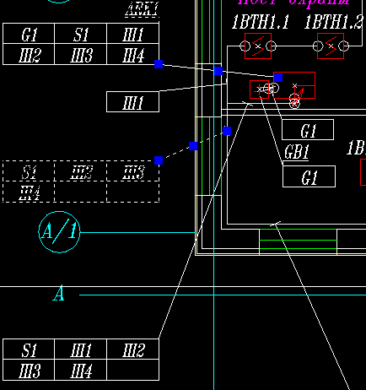

Equipment search
On a complex drawing it is difficult to quickly find the desired device or cable.
Command: | El_Find
Icon:
Menu intem: | Модель\Найти оборудование

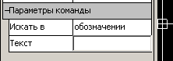

In the parameters of the command, you can enter the desired text. When you press ENTER, the search will be carried out, for any occurrence of text in the designation of the device \ cable, the device \ cable will be marked with a selection. If only one occurrence of text is found, the camera will automatically move so that the found primitive is visible on the screen completely.

Cable Journal Creation
Command: | El_Cable_Legend
Icon: | КЖ
Menu intem: | Missing??
For the created model, the cable log can be automatically created reflecting both simple and sequential connections:
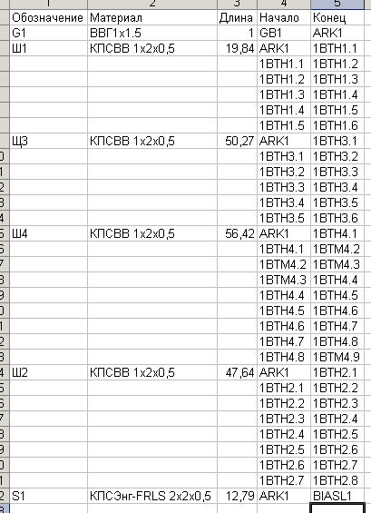
The cable log file is in CSV format and can be read by any spreadsheet processor, for example EXCEL

Creating a bill of materials
Command: | El_Material_Legend
Icon: | ВМ
Menu intem: | Missing??
A bill of materials can also be created automatically in CSV format.:
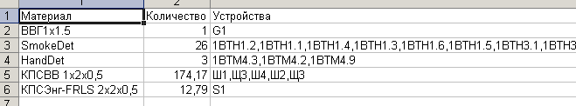

Where:
- Material - the value of the property material device \ cable
- Quantity - the total number of devices \ cables with this material
- Devices - Designations of devices \ cables with this value material

Custom setting.
Something you can customize.
Error messages
While a lot ((
Corrected, added new ones. The updated version can be downloaded at:
http://shamangrad.net/project.php?act=view&prj=zcad

